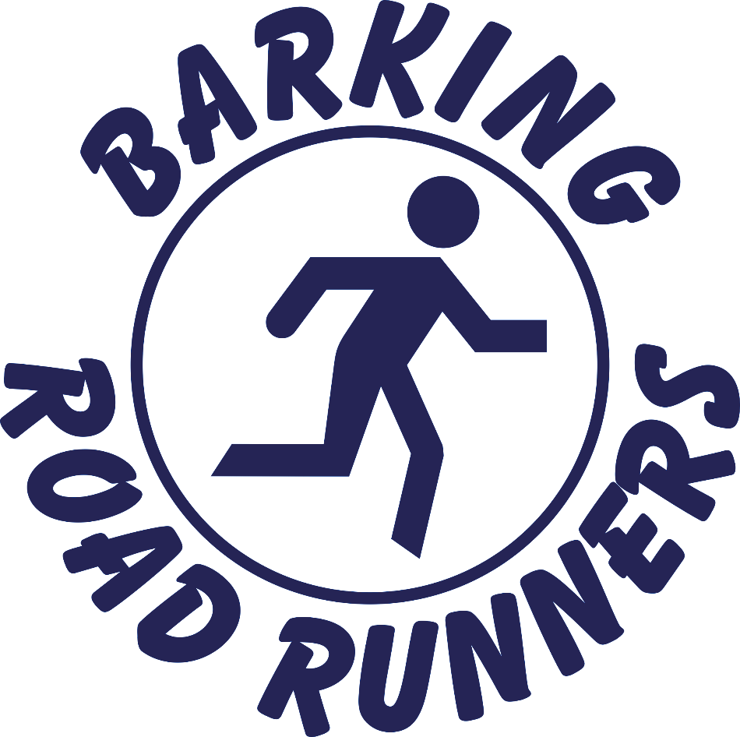

ANNUAL REPORT
2021-2022

[this page left intentionally blank]

Chair’s Foreword

Hello Barking Road Runners, and welcome to this year’s Annual Report, incorporating the Treasurer’s Report.
The Club Rules require that the Committee’s report and financial statement are presented to Club members each year at the Annual General Meeting (AGM). This is the fifth Annual Report, to provide every member with key information about the Club over the past year. The Club year runs from 1 October to 30 September.
The Report provides details of the current Committee and other members who have helped the Club during the year, the Club round-up and performance for 2021-22, and the Treasurer’s report. It was great that all the Club competitions were able to go ahead this year, although we were still feeling the impact of Covid, with it proving particularly difficult to find suitable grand prix races, and some that were chosen becoming full very quickly due to previous years’ entries being carried forward. In addition the South Essex Cross Country League (SECCL) was shifted to the spring due to Essex County Council restrictions on the use of its country parks over the winter months. Thank goodness it will be back in the winter for 2022-23!
Thanks to all the members, in addition to the Committee, who performed much-valued roles for the Club during the year including: Debbie Coyle and John Lang, who have helped with taking the Club track sessions on a Tuesday night; Trevor Parkin who has helped with set-up on Tuesdays; Melissa Lowndes who has acted as the liaison point for Club kit and also joined the London Marathon water station organisation this year; Jason for his fantastic photography and promotional activity and Jagbir for his amazing video of our Club race; Andrew and Jess for being Race Directors for the Phipps 5k; Nige for leading Thursday night runs; and all the other people who have helped out during the year (apologies if I have inadvertently missed you out). And, of course, thank you to every member who has participated in Club activities, volunteered at Club events, and supported other members. You help to make this such a great club to be part of.
As always, if you have any suggestions or feedback, please feel free to let us know; this is your Barking Road Runners and your input is welcomed.

Alison Fryatt
Chair, Barking Road Runners

Your BRR Committee
The Club is managed by a committee of members, elected each year at the Annual General Meeting. The Committee members for 2021-22 (in alphabetical order) were listed below.
- Greg Adams – Media Secretary. Greg joined the Club in November 2017. Greg is responsible for writing the news stories that appear in the Barking and Dagenham Post and in the BRR Blog. Please help Greg to fulfil his role by sending in details of your running achievements, with photos if possible.

- Rob Courtier – Club Captain. Rob joined the Club in June 1994. Rob is responsible for running related matters within the Club including motivating members to take part in races and events and, with Alison, representing the Club at interclub discussions. Rob is qualified as a Leader in Running Fitness. From this year, Rob began handing over the organisation of the Mile 14 London Marathon water station but still played an active part, especially in the recruitment of volunteers. Rob is also the liaison point with the Club charity, Richard House Children’s Hospice.

- Nikki Cranmer – Social Media Secretary. Nikki joined the Club in January 2011. Nikki publicises Club events on Facebook and WhatsApp, to ensure everyone knows what’s happening, and to encourage participation in Club events.

- Alison Fryatt – Chair. Alison joined the Club in April 2013. Alison chairs the monthly Committee meetings and approves the agendas and minutes. Since qualifying as a Coach in Running Fitness in January 2020, Alison usually leads the main track session on Tuesday evenings. She represents the Club with Rob at interclub discussions. She also produces the BRR Blog, with thanks to other members for their contributions.

- Belinda Riches – Membership Secretary. Belinda joined the Club in March 2019. Belinda processes new membership applications, membership renewals, England Athletics (EA) affiliations renewals, membership resignations and manages day-to-day liaison with EA on membership issues.

- Dee Spencer-Perkins – Club Secretary. Dee joined the Club in November 2020. Dee prepares the agendas and takes the minutes for our monthly meetings for approval by the Chair, deals with non-membership correspondence from EA, and ensures that all the necessary administrative arrangements are made for general meetings.

- Dennis Spencer-Perkins – Treasurer. Dennis joined the Club in February 2005. Dennis is responsible for maintaining and managing the Club’s bank account and presenting an up-to-date record of the Club’s financial position at each Committee meeting, and at each Annual General Meeting.

Club Round-Up 2021-22
With the Covid restrictions gradually reducing since last winter, we were able to get back to most of our normal Club activities.
Track
Our Tuesday night speedwork sessions at the Jim Peters Stadium have continued to be one of our most popular Club activities, with track proving a great place for new members to get to know us, and for all members to train in safety. The ability to pay track subs in advance directly into the Club bank account, which was started to reduce the handling of cash during Covid, has remained a popular option. Members are also becoming more comfortable with remaining after the session for refreshments and some socialising.
The cost of hiring the track each week increased from £52.50 to £54.60 in April. Even with the popularity of track sessions, this means that most weeks we are not recouping enough in track subs to cover the cost of hire, with the difference being met from Club funds. We can expect a further, inflation-based, increase in April 2023.
As you’ll see from the Treasurer’s Report, we secured some funding from England Athletics to put some members through Leaders in Running Fitness (LIRF) training, so we have more people who can take track sessions. If you would be interested, please let us know. In return for the training, we would look to a commitment to take a certain number of sessions each year.
Thursday Night Runs
The Club’s Thursday night runs start and finish at the Jo Richardson School/Castle Green Centre in Gale Street, Dagenham and are usually around six miles. We have a hardcore of members of various abilities who attend most weeks but would welcome other participants.
Sunday Morning Runs - Hainault Forest
The Club runs on the trails in Hainault Forest most Sunday mornings (except on race days). The runs start at 9.30am in the car park in Fox Burrow Road, last around 60-90 minutes and always finish with refreshments at the Global Café. All abilities are welcome.
August Bank Holiday (Phipps 5K) Race
Andrew Gwilliam and Jess Collett jointly took on the role of Race Director for our August Bank Holiday race, the Phipps 5k, and did a great job of it! This year there were 269 finishers, compared to 238 the year before, with times ranging from 16.43 minutes to 50.49 minutes. As you’ll see from the Treasurer’s Report, the race makes a valuable contribution to Club funds each year so thank you to Andrew and Jess, and to all other members who helped to make our race one of the most popular in the East London fiVes Interclub Series (ELVIS).

parkrun
Barking Road Runners has very close links with local parkruns, having been actively involved in setting many of them up. Club members are involved at all levels, from Event Director to Run Director to regular volunteers and, of course, as runners. Barking parkrun in particular has proved a good way source of new members for the Club.
Media
Greg Adams continued in the role of Media Secretary, giving up his Sunday afternoons and evenings to collate information about the races that members have participated in, and submitting his weekly article to the Barking and Dagenham Post. Please make Greg’s life easier by posting details of the races you have participated in, including photos, if you want a chance to be featured in the paper.

Club Kit

Melissa Lowndes has continued to be our Club kit contact. Our kit supplier is Uniform7, a local company. The link to the BRR Uniform7 microsite can be found below, and on the links tab of the Barking Road Runners website. Uniform7’s main business is the provision of uniforms for local schools and it often proves difficult to obtain kit at short notice: not great if you have a race coming up. We are therefore exploring other kit suppliers. It is likely that the kit will be more expensive, but we hope it will be better quality and available more promptly. In the meantime, please order via this link:
https://uniform7.co.uk/product-category/custom-merchandise/barking-road-runners/

Sportsshoes.com

The Club is signed up to the Sportsshoes.com membership scheme, which gives members of participating clubs a 10% discount on all items (except Brooks) on the Sportsshoes.com website and free postage and packing, worth £4.99. A new discount code is issued via the blog each month. Please don’t share this more widely; it is intended for Club members only.
Members may also get a 10% discount at the Run Active shop in Upminster. It is a good idea to go to a proper running shop to get your gait analysed if you are thinking of trying a different type of running shoe. The address is:

181 St Mary's Lane
Upminster
Essex
RM14 3BL
01708 970350
upminster@runactive.co.uk

Membership
For 2022 the Committee made the decision to resign unpaid members from the Club after a period of three months had passed with no payment / no response (this follows two years of limited activity due to Covid where we did not actively follow up members who had not paid). Overall membership numbers reduced due to this. However the number of paid members increased for 2022. With five membership applications in process, expectation is that we will end 2022 with similar number of members as at end 2021.
As at 31 October 2022, the numbers were (2020 - 21 figures in brackets, for comparison):
• Total membership: 112 (118)
• Paid members: 110 (88) - 2 members recently joined yet to pay
• 1st claim (England Athletics (EA)): 53 (48)
• 1st claim (non-EA): 38 (49)
• 2nd claim: 9 (11)
• Life Members: 10 (10) of which
- 1st claim, with EA: 1 (3)
- 1st claim, non-EA 8 (6)
- 2nd claim: 1 (1)
(5) more membership applications are currently being processed.
This was the fourth year of processing memberships via the EA electronic membership portal. Noting that EA charges a handling fee for each financial transaction through the Portal, this year we asked members if they wished to pay the fee directly to EA, or via the Club. By paying all the money paid via the Club in one go, we minimised the amount of your money that was lost to charges. For next year, we will be asking for subscriptions payments in March, to ensure seamless membership from the start of the new Club year in April.
A reminder that you are responsible for maintaining your own details on the EA members’ portal: https://myathletics.englandathletics.org/portal/Members/Login. If you are unable to update your details directly, please let a committee member know.
You may not be aware, but the Club pays a member body affiliation fee for being part of England Athletics. For the coming year, the fee will remain at £150. As part of the affiliation fee, the Club receives public liability insurance, is able to apply for our annual Club race to be EA licensed, and also gets a guaranteed place in the London marathon (based on the number of EA registered members). We can also participate in EA events and initiatives, and receive discounted rates for EA education like Leader in Running Fitness and Coach in Running Fitness training.
For 2023, the cost of athlete registration with EA will increase by £1 from £16 to £17. Registered athletes get a £2 discount for every EA-licensed race they sign up for so, if you do nine licensed races, you will get your money back. You also get discounts from EA partner organisations, though do check if the discount is better than you can get elsewhere. See the EA website for further details.
2021-22 Performance
Club Handicap 5K
The Club Handicap competition allows all members to compete against each other on a level playing field. Start times are phased, with the slowest runner starting first and the fastest runner starting last, with the aim of everyone having an equal chance of winning.
The summer handicap competition was organised by Greg Adams over the Barking parkrun course, using the results of the winter virtual handicap to set the starting handicap times. It was fantastic to see each of the seven races in the competition being won by a different member, which shows that everyone really does have a chance of winning.
The results of the competition (best four of seven races) were:

Position | Name (points)
1 | Nikki Cranmer (492)
2 | Nige Swaby (490)
= 3 | Martin O’Toole, Les Jay (484)

Internal Club ELVIS Competition
BRR is proud to be a founding member of ELVIS league, the annual competition for clubs in the East London area. This year, the competition was back to its full complement of eight races, with the Harold Wood Running Club race back in the calendar after being denied landowner permission in 2021.
BRR holds its own, internal, ELVIS competition, to reward members who represented the Club at the ELVIS races. The overall results are based on the best five of seven races: for fairness, the Phipps 5K is not included when awarding points as most members are required to volunteer at our own race.
Position | Men (points) | Position | Women (Points)
1 | Paul Withyman (500) | 1 | Jess Collett (498)
2 | Stuart Mackay (490) | 2 | Belinda Riches (490)
3 | Martin Page (484) | 3 | Isabel Pinedo Borobio (484)

Grand Prix
Each year the Committee selects ten races over different distances, including at least one 5 miles, 10 kilometres, 10 miles and half-marathon race. It proved difficult to select races this year, with many organisers leaving it late to announce their races due to Covid concerns, and other races filling up more quickly than usual due to carried over entries from previous years. To take account of this, the Committee included an additional race in the competition to give members a better chance of being able to enter. But it still proved difficult to spread the races out over the GP season (usually March to October/early November). We hope to do better next year, although we are in the hands of race orgainsers.

The results of the Grand Prix Competition (best six of 11 races) were:

Position | Men (points) | Position | Women (Points)
1 | Paul Withyman (600) | 1 | Debbie Coyle (600)
2 | Martin Page (597) | 2 | Alison Fryatt (594)
3 | Les Jay (575) | 3 | Joyce Golder (591)

Internal Club Chingford League Competition
BRR was invited to join the Chingford League a few years ago. The Club pays an annual subscription fee to be part of the League, which means that members can then race for free. The League competition usually includes three races on tarmac plus three cross country races, then culminates in March with a 4x3000m cross country relay event. There are six senior team categories (teams of six): Men's A, B and Vet teams, Women’s A, B and Vet teams. The A teams are divided into two divisions.
For the first time this year, given the growing popularity of the League, there was also an internal club competition, based on the best four of six races (excluding the end-of season relays).
Position | Men (points) | Position | Women (Points)
1 | Joe Stacey (400) | 1 | Rosie Fforde (399)
2 | Adrian Davison (391) | 2 | Joyce Golder (392)
3 | Daniel Plawiak (383) | 3 | Isabel Pinedo Borobio (390)

We performed strongly in last year’s Chingford League and hope this year there is a chance of promotion to the first division for our Men’s A Team.
South Essex Cross Country League
The Club participates in the South Essex Cross Country League. The League consists of clubs from the East London and South Essex area and takes place in country parks within Essex. It usually consists of five races held across the autumn/winter (between November and February). For 2021-22, the League was not able to use the parks in winter, so the competition was moved to the spring/summer instead; just not right for cross country but it did hold us back – BRR was first second division team in all but one of the races, where we placed second, earning us promotion to the first division. Now we just have to stay up there! Thanks to all the runners who made our promotion possible, and also to the volunteers who helped on race day; all were rewarded with a commemorative mug (please let Dennis know if you haven’t received yours yet).
The results of BRR’s internal XC competition (best four of five races) were as follows:
Position | Men (points) | Position | Women (Points)
1 | Steve Philcox (396) | 1 | Debbie Coyle (400)
2 | James Lowndes (389) | 2 | Joyce Golder (391)
3 | Jagbir Bassi (386) | 3 | Isabel Pinedo Borobio (382)

Members’ Cup
Rob Courtier and Greg Adams were joint winners of the 2021 Members’ Cup for 2020. The results of the 2022 vote will be announced at the Presentation Night in early December.
Other Trophies
The club also awards trophies for the most improved male and female runner each year, based on performance across Club competitions. As there is very little comparative date from the year before (to measure improvement against), the Committee is deciding if trophies should be awarded for 2021-22.
Club Charity
Richard House Children’s Hospice was the Club charity for 2021-22. The outcome of the poll of members regarding the Club charity for the year ahead will be announced in December 2022. A change in Club rules at the 2021 AGM means that Club members who are allocated a Club Marathon place are no longer required to collect money for the Club Charity but can instead choose their own good cause (or, indeed, no cause).
BRR Treasurer’s Report
1 October 2021 – 30 September 2022

Overview, 2021-2022
Once again, our finances show that we have a surplus of income against expenditure. For the year 2021-2022 this surplus is £953.83.
The two tables that accompany this Report show income and expenditure for 2020-2021 for comparison (Table 1) and also for the closing Club year 2021-2022 (Table 2).
Accounting Basis
The Club’s financial year runs from 1 October to 30 September.
The accounts are prepared on a cash basis, i.e. income and expenditure are recognised when money actually changes hands rather than when bills are received, or goods and services are used. This can result in what appear to be mismatches (e.g. if we pay for Track in advance it will appear in the 2022-2023 accounts, even though some Track nights might take place in the next financial year).
Membership
In 2021-22, income from this source was up by 20% on the previous year (a total of £1,459.38) as opposed to £1,213.45 in the previous year. This year, almost all membership has come to us directly, rather than via England Athletics, who apply a service charge to each payment processed directly by them.
Affiliations
This year, a total of £290 was paid in Club affiliations to the Chingford League and England Athletics.
BRR Training
The Club was given £300 by the EA towards Leader in Running Fitness training, none of which has yet been spent. We are currently looking for volunteers to do this training, with a view to going on to assist with Track sessions for the Club.
One Member took a First Aid/Leadership course.
Track Hire
A total of £2,193 was received in Track subscriptions during the year 2021-2022, and total expenditure was £2,814.68, a deficit of £621.68. In reality, some of the income was paid in advance (£1,495), so it is hard to calculate the exact deficit for the year.
On a weekly basis, it is currently £54.60 to hire the track, with an increase expected in April 2023. Our subscription rate is £2 per session, and the Club has been subsidising this regular event.

London Marathon
These figures refer to the Marathon which took place in October 2021. We received £150 as payment for staffing the Water Station, and spent £71.59 on post-event refreshments.
BH5K
This year, the popular BH5K ELVIS (Phipps 5k) race generated a surplus of £1,029.46. (Trophies are accounted for elsewhere in this Report.)
5K Handicap
Income for this event was up on the previous year by £47, increasing to £137. Expenditure was £70 (£10 prize money for each winner). Other income will contribute to the cost of the trophies. Asking members to pay £5 in advance (to cover all 7 races – a £2 discount) seemed to work quite well.
Cross Country
Expenditure here exceeded income by £298, as each runner was subsidised by £2 per event.
Social Events
No social events were organised this year, although there were celebratory drinks post-Marathon at the Prince of Wales pub.
Website
The cost of running the website remains very similar to the previous year. The hosting fee was £158.28, and renewal of the domain name [.org.uk] was £21.58.
However, repairs to the website cost £56 in 2021-22.
Miscellaneous
During this year, £142.09 was received from Easyfundraising. Other miscellaneous expenditure is itemised in Table 2, and includes (among other things) the room booking fee for the AGM, and 10 marker flags for use at our own cross-country events. Bank/cheque charges of £47.80 were incurred during the year.
In Summary
In the last Club year, BRR continued to enjoy a healthy bank balance and a steadily growing membership.
Our end of year balance shows a modest surplus of income over expenditure of £958.83, and on 30th September 2022 we had £11,838.88 in our bank account.

Table 1: BRR Income and Expenditure
1 October 2020 – 30 September 2021
Event | Income  £ |  | Expenditure  £
Track income | 751.00 |  | 0
Track subs in advance | 906.00 |  | 0
Track hire | 0 |  | 1,562.00
Kit | 83.00 |  | 132.00
Membership (directly to BRR Account) | 1,084.00 |  | 0
Membership (via EA to BRR Account) | 129.45 |  | 0
Individuals’ EA Membership | 495 |  | 480
BRR Club EA Affiliation | 0 |  | 150.00
BRR Chingford League Affiliation 2020/21 | 0 |  | 100.00
BRR Chingford League Affiliation 2021-22 | 0 |  | 100.00
London Marathon Coach Seats | 73.05 |  | 73.05
BRR Training | 0 |  | 40.00
Winter Virtual Handicap | 0 |  | 26.00
Handicap 5K | 90.00 |  | 70.00
BH5K | 2,611.00 |  | 1,832.76
Website Hosting April-September 2019/20 | 0 |  | 79.14
Website Hosting 2020/21 | 0 |  | 152.28
BRR Domain Name (.org.uk) |  |  | 21.58
Trophies (HC, XC, Members’ Cup) | 0 |  | 136.33
Miscellaneous | 53.56 |  | 119.50
Totals | 6,275.86 |  | 5,074.64

Table 1: BRR Income and Expenditure
1 October 2021 – 30 September 2022
Event | Income  £ |  | Expenditure  £
Track | 698.00 |  | 139.28
Track Subs in Advance | 1,495.00 |  | 0
Track hire | 0.00 |  | 2,675.40
Kit | 54.00 |  | 0.00
BRR Membership | 1,384.38 |  | 0.00
2nd claim Members | 75.00 |  | 0.00
EA Members | 880.00 |  | 880.00
BRR's Club EA Affiliation | 0.00 |  | 150.00
BRR's Chingford League Affiliation 2022/23 | 0.00 |  | 140.00
BRR Training | 300.00 |  | 65.00
Handicap 5k | 137.00 |  | 70.00
Cross Country | 447.00 |  | 745.00
BH5K (Phipps 5k) | 2,735.60 |  | 1,706.14
Trophies, HC/XC/Members cup/ELVIS/BH5k/Mugs | 0.00 |  | 555.08
Website Hosting | 0.00 |  | 158.28
BRR's Domain name renewal .org.uk | £0.00 |  | 21.58
Website repair | £0.00 |  | 56.00
London Marathon water station payment | 150.00 |  | 0.00
London Marathon Coach seats refund to RC | 21.00 |  | 21.00
London Marathon Post refreshments | 0.00 |  | 71.59
Easyfundraising | 142.09 |  | 0
Bank/Cheques charges | 0 |  | 47.80
Miscellaneous items listed below | 0 |  | 0
Richard House, BRR Christmas card donation | 100.00 |  | 100.00
Daniel Plawiak's Donation | 2.00 |  | 0
Marker Flags | 0 |  | 12.09
Ron Viall’s Gift for supplying hot drinks at XC | 0 |  | 13.00
AGM room booking fee | 0 |  | 40.00
Alison Fryatt to Dennis SP (Phipps 5k correction) | £27.58 |  | 27.58
Total Accounts for 2021-2022 | 8,648.65 |  | 7,694.82

